|  |  |  |  |  |  |  |  |  |  |  |  |  |
| --- | --- | --- | --- | --- | --- | --- | --- | --- | --- | --- | --- | --- |
| |  |  | | --- | --- | | Rotini Pasta | Bell Pepper | | Zucchini | Cherry Tomatoes | | Green Onion | Mixed Olives | | Parmesan Cheese | Mozzarella Balls | | Red Wine Vinegar | Salt | | Pepper | Olive Oil |  Ingredients Without Measurements |

|  |
| --- |
| Ingredients With Measurements  * 1 pound dried rotini pasta * 1 cup sliced bell pepper (1 medium) * 1 cup thinly sliced zucchini (1/2 medium) * 1 cup halved cherry tomatoes * 1/3 cup thinly sliced green onions (5 to 6) * 1 cup (4 ounces) halved mixed olives * 1 cup (2 ounces) grated parmesan cheese * 1 cup (6 ounces) fresh mozzarella balls, chopped * 1/3 cup red wine vinegar * ½ teaspoon salt * ½ teaspoon fresh ground black pepper * ½ cup extra-virgin olive oil |

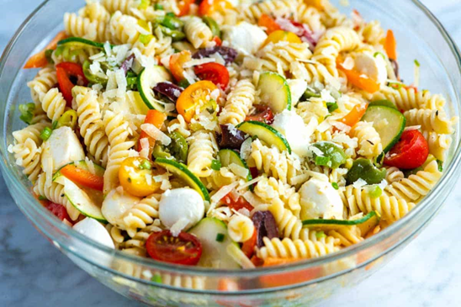Pasta Salad

|  |
| --- |
| Recipe Bring a large pot of salted water to a boil. Add pasta and cook until tender, 6 to 10 minutes (check the package for recommended cook time). Drain and rinse well under cold water.  While the pasta cooks, in the bottom of a large bowl, make the dressing. Whisk the red wine vinegar, salt, pepper, oregano, and the olive oil until blended. Add the drained and rinsed pasta to the dressing and mix well.  Stir in the bell pepper, zucchini, tomatoes, green onions, olives, parmesan, mozzarella. Taste for seasoning. |